- Home Page

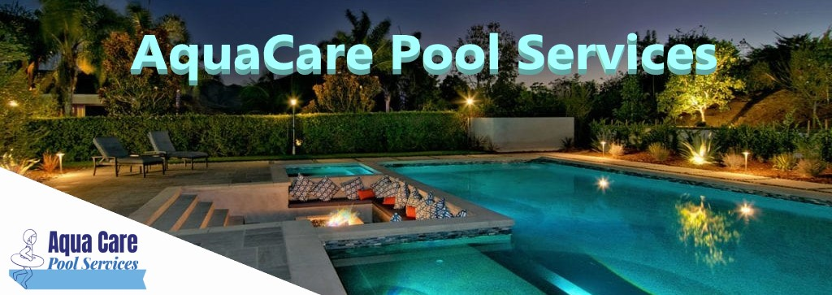

Below are links to each page:

Home Services Contact Photos Social Media

(About) Write a few paragraphs about the company, what local areas they service, their experience in the industry, a picture or two, and a few testimonials.

Try different colors for backgrounds to see which works best. Light colors: possibly green or the business colors; if nothing looks good, make background white or off-white.

**Blockquote from work done.**

- Services Page



Company name (AquaCare) and logo.

Use company pictures

Below are links to each page:

Home Services Contact Photos Social Media

List the different services offered with a bulleted list of what is provided for each service and a picture for each type of service.

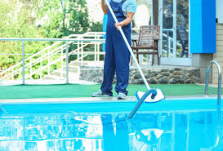

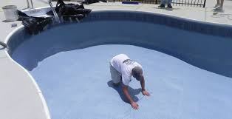

- Contact Page

Different picture (photo of business?) with company name (AquaCare) and logo.

Below are links to each page:

Home Services Contact Photos Social Media

**Address:**

1234 Something Road Google map location

Virginia Beach, VA 123??

**Hours of Operation:**

M-F: ??:??am to ??:??pm

Sat/Sun: ??:??am to ??:??pm Request a quote:(form)

Name

**Phone:** Email

(757)XXX-XXXX Address

Phone

**Email:** Pool Service (drop down menu)

[aquacarepoolservice@xxxx.com](mailto:aquacarepoolservice@xxxx.com) Other (as needed)

- Photo Gallery Page

Company name (AquaCare) and logo.

Below are links to each page:

Home Services Contact Photos Social Media

Photos of work done with a few more testimonials. Some before and after pictures.

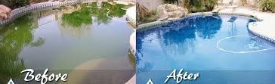

- Social Media Page

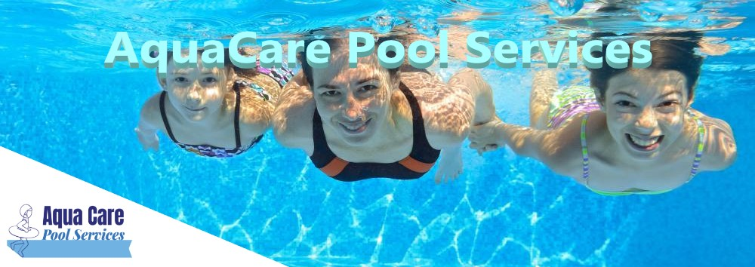

Below are links to each page:

Home Services Contact Photos Social Media

**Follow us on FaceBook:**

 (Link to FaceBook page)

**Follow us on Instagram:**

instagram.jpg (Intstagram account name [link?])

**Follow us on Twitter:**

 (Twitter account name [link?])

**Follow us on ???:**

(Other account name [link?])